


Calculator Orders for
Mary Mackillop Catholic Regional College Students

Please place your order online between:
1st October 2020 – 10th January 2021

*** Please note: Once your order is placed online it will be delivered directly to your nominated address and you will pay a delivery fee of $14.95 (incl. GST). ***
___________________________________________________________________________________________________________________________

Step 1: Go to the Abacus website: http://www.abacuscalculators.com.au

Step 2: Enter the School ID code and type into box as shown on Homepage:
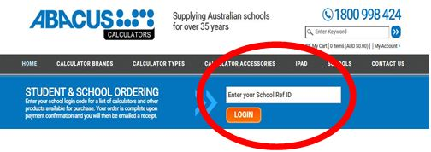
MARYMACVIC

Please Note: You must do this step first to avoid the delivery fee. Please do not search for the product before entering the School ID code.

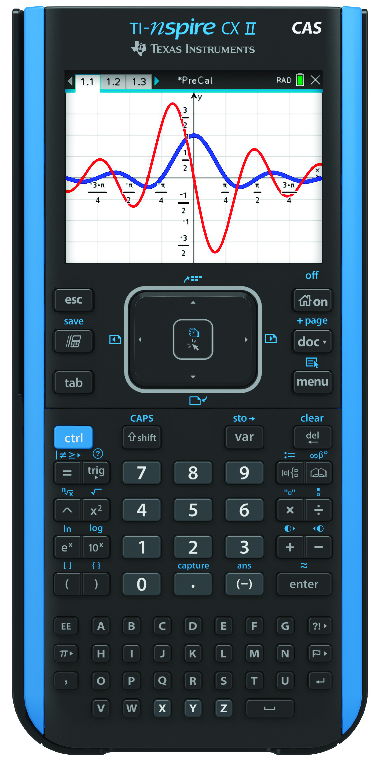
Step 3: Select the product/s you want to order.
(Please note: No refunds given on incorrect purchase.)

- TINSPIRECX II CAS Calculator plus
FREE Protective Padded Case $ 224.40 (incl. GST)
- TI Wall Charger Adaptor $ 12.00 (incl. GST)
- TI Rechargeable Battery (SPARE) $ 18.00 (incl. GST)

Step 4: Calculators ordered by the 10th January 2021 will be available for collection from Mary MacKillop Catholic Regional College week beginning 1st February 2021.

If you have any queries, please call 1800 998 424.

Please see conditions below:
TINSPIRECXII CAS calculators are covered by a 3 - year replacement warranty.
Warranty: Please keep a receipt copy as proof of purchase. The student’s name will also be registered at Abacus.
Company Policy: No refunds given on incorrect purchase.

