INDIVIDUAL ANAPHYLAXIS MANAGEMENT PLAN

This plan is to be completed by the principal (or their delegate) on the basis of information from the student's medical practitioner (ASCIA Action Plan for Anaphylaxis) provided by the parent, guardian or carer.
It is the parent’s, guardian’s or carer’s responsibility to provide the school with a copy of the student's ASCIA Action Plan for Anaphylaxis containing the emergency procedures plan (signed by the student's medical practitioner) and an up-to-date photo of the student - to be appended to this plan; and to inform the school if their child's medical condition changes.

School Information
Name
Location
Phone

Student Information
Full Name
Date of Birth |  | Grade / Year level
Severely allergic to

Other health conditions

Medication at school
Emergency care to be provided at school
Storage location for adrenaline autoinjector (device specific) (EpiPen®)

Emergency Contact - Parent / Guardian / Carer Contact
Name |  | Name
Relationship |  | Relationship
Home phone |  | Home phone
Work phone |  | Work phone
Mobile |  | Mobile
Address |  | Address

Emergency Contact - Alternative Emergency Contact (if Parent / Guardian / Carer not available)
Name |  | Name
Relationship |  | Relationship
Home phone |  | Home phone
Work phone |  | Work phone
Mobile |  | Mobile
Address |  | Address

Medical practitioner contact
Name
Phone

ENVIRONMENT
To be completed by principal (or their delegate).
Please consider each environment/area (on and off school site) the student will be in for the year, e.g. classroom, canteen, food technology area, sports oval, excursions and camps etc.
Risk minimisation strategies are available at Chapter 8 of the Department of Education and Training Anaphylaxis Guidelines.
Name of environment/area:
Risk identified | Actions required to minimise the risk | Who is responsible? | Completion date?
Name of environment/area:
Risk identified | Actions required to minimise the risk | Who is responsible? | Completion date?
Name of environment/area:
Risk identified | Actions required to minimise the risk | Who is responsible? | Completion date?
Name of environment/area:
Risk identified | Actions required to minimise the risk | Who is responsible? | Completion date?

Name of environment/area:
Risk identified | Actions required to minimise the risk | Who is responsible? | Completion date?

ASCIA Action Plan for Anaphylaxis
ASCIA Action Plans and First Aid Plans for Allergy and Anaphylaxis assist in emergency treatment of severe allergy and anaphylaxis. The plans are medical documents that can be completed online and saved as PDFs, by the treating medical or nurse practitioner.
Parents, guardians and carers (via their medical practitioner) can access the ASCIA Action Plan for Anaphylaxis from the Australasian Society of Clinical Immunology and Allergy (ASCIA) website: https://www.allergy.org.au/hp/anaphylaxis/ascia-action-plan-for-anaphylaxis

An example of the ASCIA Action Plan for Anaphylaxis template is shown below:
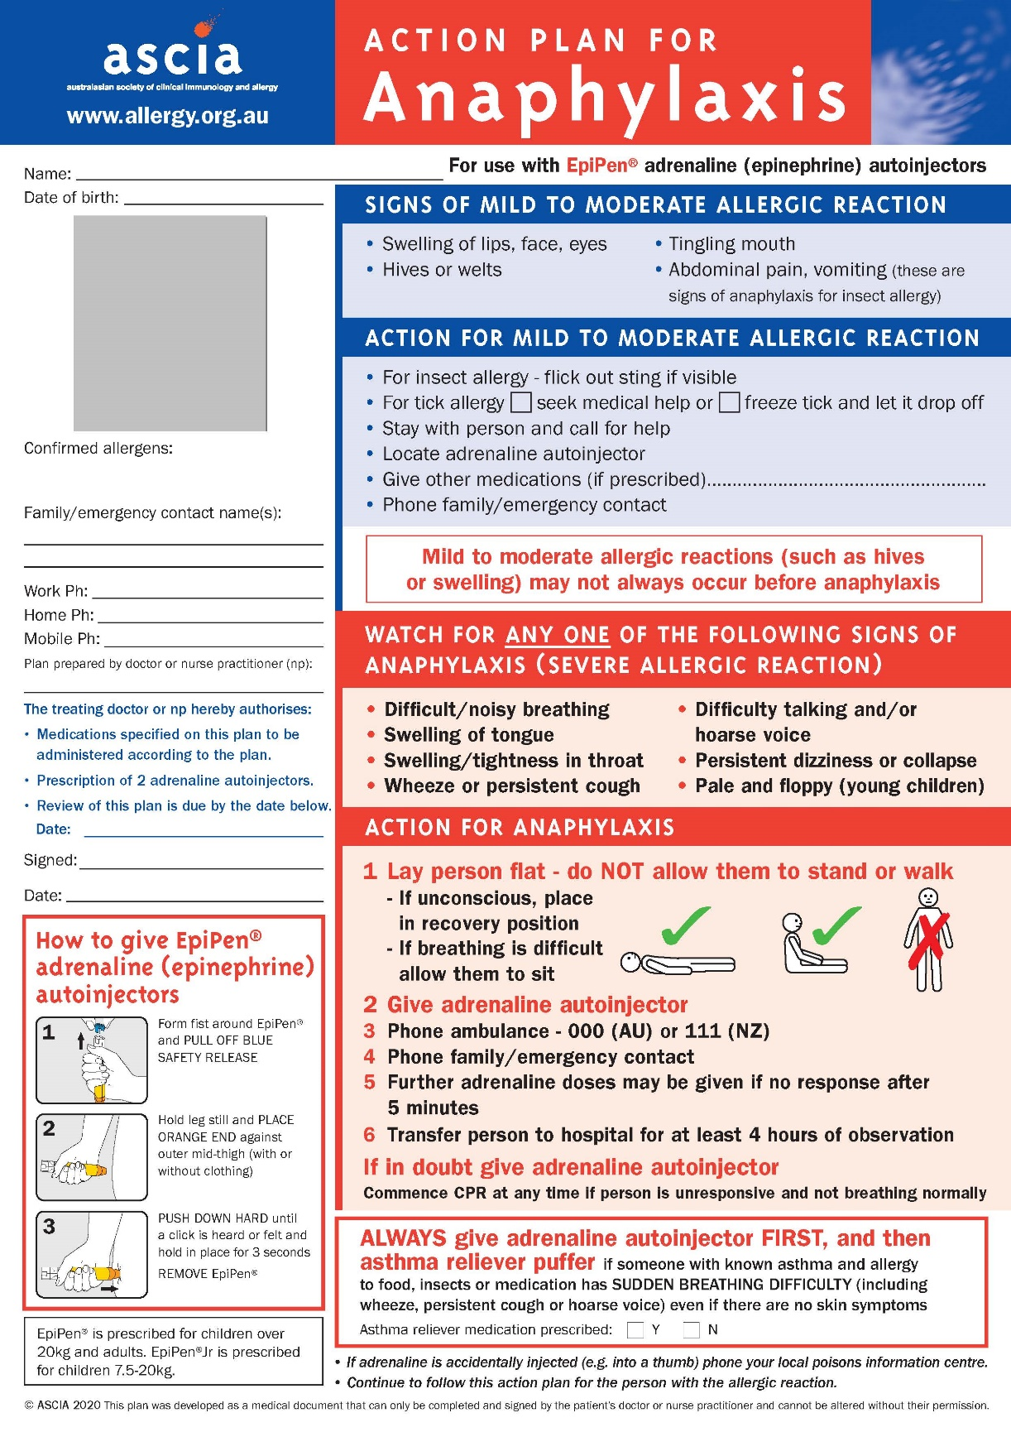

Individual Anaphylaxis Management Plan Review
This Individual Anaphylaxis Management Plan will be reviewed on any of the following occurrences (whichever occurs first):
- annually
- if the student's medical condition, insofar as it relates to allergy and the potential for anaphylactic reaction, changes
- as soon as practicable after the student has an anaphylactic reaction at school
- when the student is to participate in an off-site activity, such as camps and excursions, or at special events conducted, organised or attended by the school (e.g. class parties, elective subjects, cultural days, fetes, incursions).

PARENT, GUARDIAN OR CARER CONSENT
- I have been consulted in the development of this Individual Anaphylaxis Management Plan.
- I consent to the risk minimisation strategies proposed.

Signature
Full name
Date

PRINCIPAL (OR THEIR DELEGATE) ACKNOWLEDGEMENT
I have consulted the parents, guardians or carers of the student and the relevant school staff who will be involved in the implementation of this Individual Anaphylaxis Management Plan.
Signature
Full name
Date

