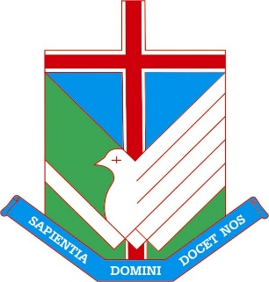
Mary MacKillop College
South Gippsland

Welcome and thank you for your interest in applying for a teaching position at Mary MacKillop College!

Mary MacKillop College is located in the picturesque town of Leongatha in South Gippsland, approximately 135km South East of Melbourne. We are a one campus secondary College catering for 620 students between Years 7 and 12.

Checklist for application:
- Cover letter
- Current curriculum vitae
- Three referees
- Application form
- Copies of qualifications
- Copy of VIT registration

Please return this completed form and all relevant information to:
Mrs Carly Kitchingman
Principal’s Personal Assistant
ckitchingman@mmcrc.catholic.edu.au

All information provided for the purpose of this application will be kept confidential and destroyed at the conclusion of the recruitment process.

